**1)Unix and Linux difference**

**UNIX** OS.

* The source code of Unix is not available for the general public.
* Unix primarily uses Command Line Interface.
* Unix is not portable.
* Unix has a rigid environment of the hardware. Hence, cannot be installed on every other machine.
* Unix is mainly used in Server Systems, Mainframes and High End Computers.
* Different Versions of Unix are AIS, HP-UX, BSD, Iris, etc.
* Unix installation is comparatively costlier as it requires more specific hardware circuitry.
* The file systems supported by Unix are as follows: zfs, js, hfx, gps, xfs, vxfs.
* Unix is developed by AT&T Developers.

**Linux** OS.

* The source code of Linux is freely available to it’s users.
* Linux primarily uses Graphical User Interface with an optional Command Line Interface.
* Linux OS is portable and can be executed in different hard drives.
* Linux is very flexible and can be installed on most of the home based PCs.
* Linux is used on home based PCs, Mobile Phones, Desktops, etc.
* Different version of Linux are Ubuntu, Linux Mint, RedHat, Solaris, etc.
* Linux installation is economical and doesn’t require much specific and high end hardware.
* The file systems supported by Linux are as follows: xfs, ramfs, nfs, vfat, cramfsm, ext3, ext4, ext2, ext1, ufs, autofs, devpts, ntfs.
* Linux is development by an active Linux Community worldwide.

OR

* **UNIX**
* UNIX is multitasking and multiuser operating system created by Ken Thompson, Dennis Ritchie at AT&T in 1970. Initially intended for use inside the Bell System.
* **Linux**
* Linux is unix-like operating system released as free and open source. Linux is created by Linus Torvalds. Linux distributions uses Linux kernel to build the whole operating systems. Not only a Linux, BSD unix also a unix-like operating system. But Linux has more volunteers and evolved rapidly.

**2) Linux File System Structure**

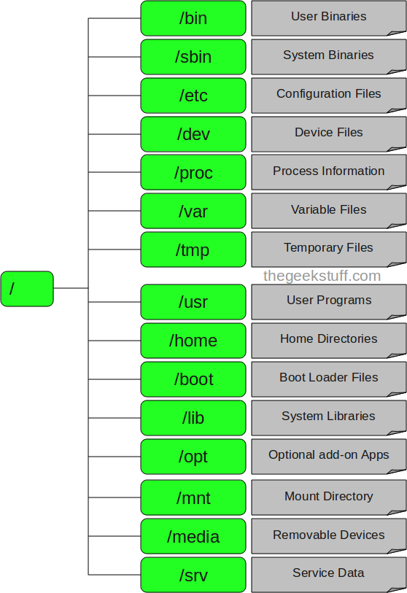

3) B**asic Linux/Unix Commands**